

MIFFARE MANAGEMENT

TECHNICAL REFERENCE



October 20, 2014

Kwik Kian Gie School Of Business

JL.YOS SUDARSO KAV.87, SUNTER, JAKARTA UTARA

# DAFTAR ISI

Contents

DAFTAR ISI 1

TECHNICAL REQUIREMENTS 2

DATABASE SCHEMA 2

FLOW CHART & TABLE RELATION 2

DATA STUCTURE 3

PATR0002 DOSEN 3

SATR0002 MAHASISWA 4

SATR4010 MAPPING NIM DENGAN MIFARE 4

CDMCSM MASTER CUSTOMER 5

CMDMIFARE MASTER MIFARE 5

CSTR5000 LOG TRANSAKSI SALDO KARTU 5

# TECHNICAL REQUIREMENTS

|  |  |  |
| --- | --- | --- |
| Item | Value | Optional |
| File Server | \\172.16.0.50\Photo |  |
| Automatic Create Folder | \Karyawan\nik.jpg  \Program\Studi\Jurusan\Tahun\nim.jpg |  |
| JPEG File | 227 * 340 Pixel |  |
| .NET FRAMEWORK | .NET FRAMEWORK 4 |  |
| Reporting | Crystal Report Redistribution 13.0.9 |  |
| Database | MySQL 5.0 Community |  |
| Connector | MySQL Connector NET 6.8.3 |  |
| Reader | Mifare Reader | YES |
| Printer | Evolis Card Printer-Badgy | YES |
|  |  |  |

# DATABASE SCHEMA

|  |  |
| --- | --- |
| Database Schema | iap_db/172.16.0.12 |
| Database Schema | Canteen/172.16.0.24 |

## FLOW CHART & TABLE RELATION



# DATA STUCTURE

## PATR0002 DOSEN

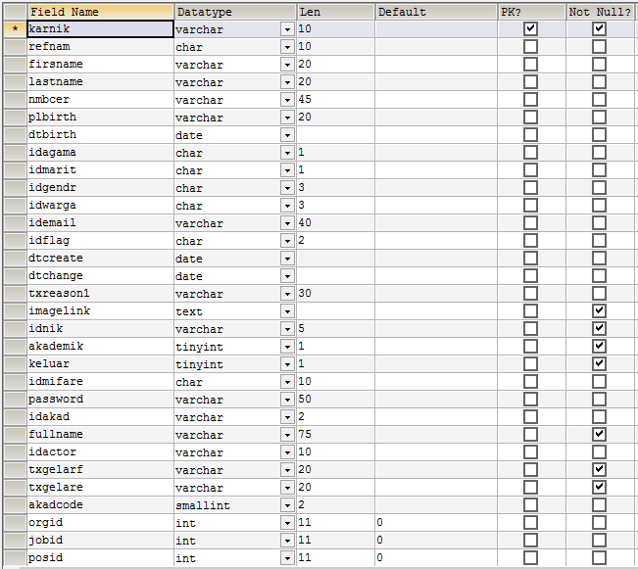

## SATR0002 MAHASISWA

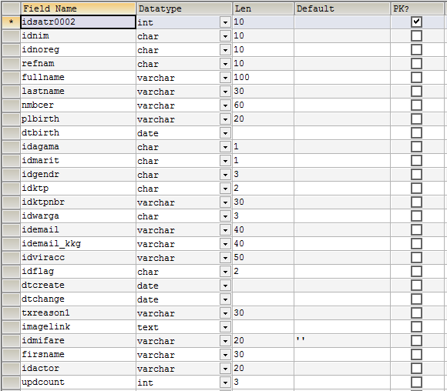

## SATR4010 MAPPING NIM DENGAN MIFARE

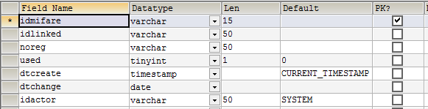

## CDMCSM MASTER CUSTOMER

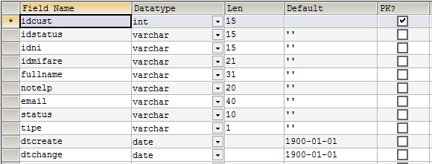

## CMDMIFARE MASTER MIFARE

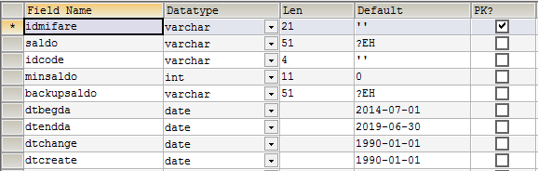

## CSTR5000 LOG TRANSAKSI SALDO KARTU

